# Day-1 Hands-on Labs: Getting to Know your System

## Lab-1: Understand your Distribution

1. Find the distribution name, version, and release information (**/etc/os-release**, **lsb_release -a**). What’s the difference you see in both?

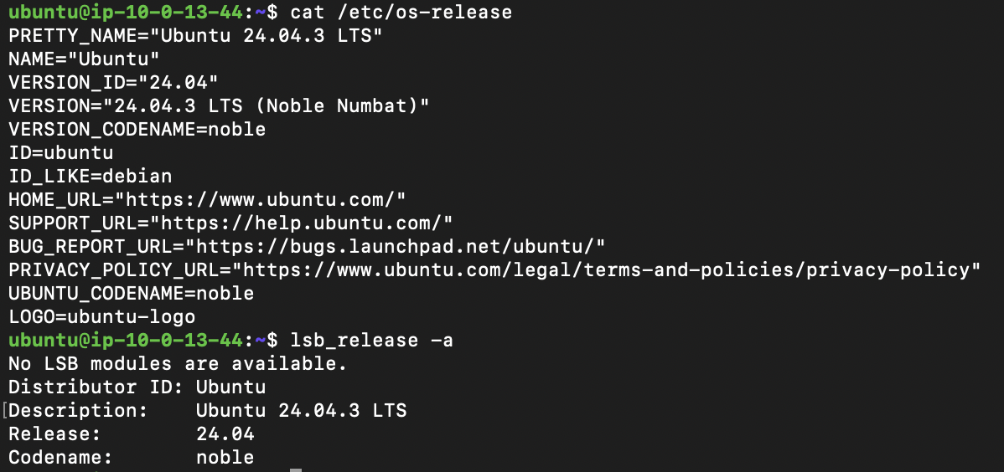

1. Check which package manager the system uses (**which yum || which apt**).



1. Discover the kernel information of your system (**uname –r**).



1. Check how long the system has been running (**uptime**).



## Lab-2: Using man Pages

1. Identify which section of the man pages documents file formats and conventions.

Ans : Section 5 documents file formats and configs

Section 7 documents overview, conventions, and miscellaneous

1. Use **man ls** and explain what the **-r** option shows. What are the other options it can be used with?

Ans : ls -r ­–– -r denotes reverse order

ls can be used with –[aAbBcCdDfFgGhHiIklLmnNopqQrRsStTuUvwxXz1]

1. With the help of **–k** and **–K** based keyword search methods, find the command that’s responsible for changing the age of passwords.

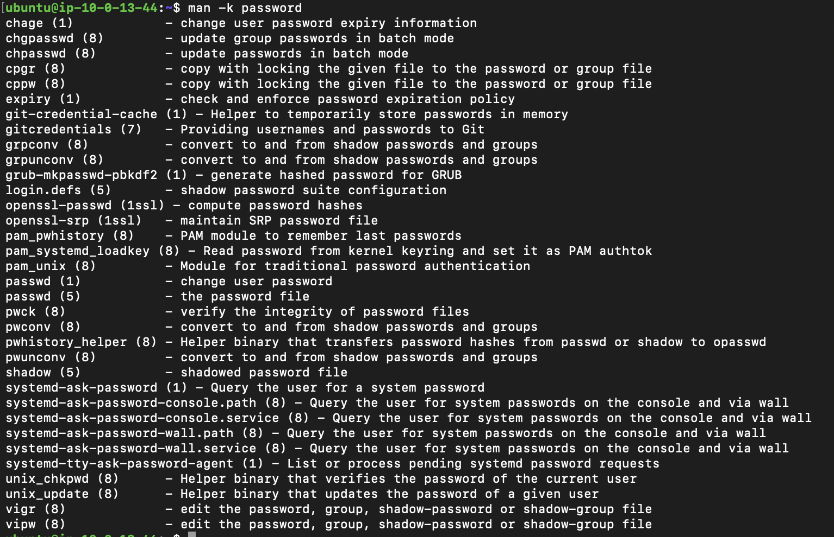

## Lab-3: The Shell and Its Modes

1. Identify which shell you are currently running (**echo $SHELL**).



1. Set the default editor for your shell as Vim.

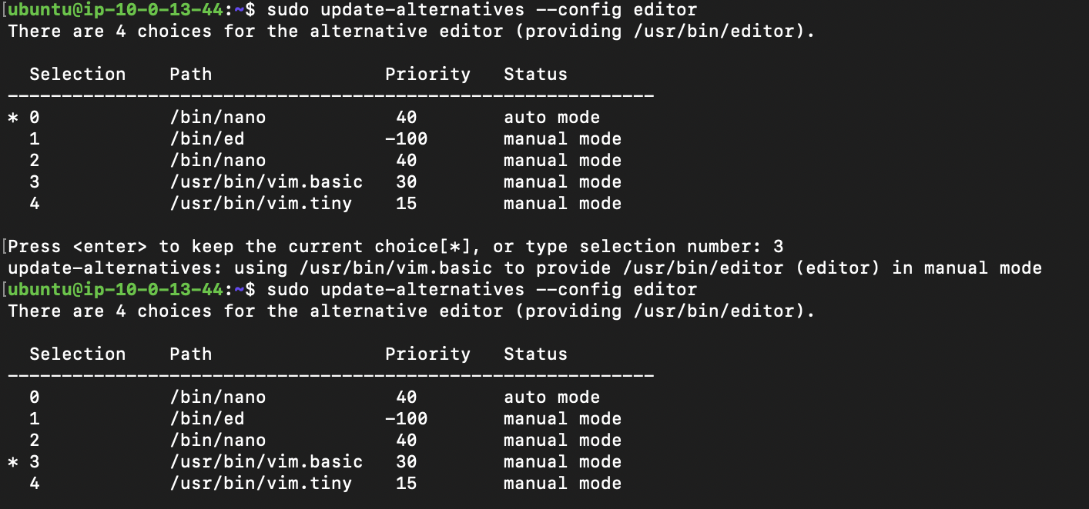

1. Write a simple script named **hello.sh** that prints “Hello, <your-name>!” and run it.

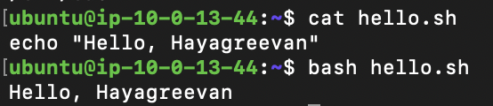

## Lab-4: Understanding the File System

1. In **/proc**, find the file that shows system uptime.

Ans : uptime

1. In **/etc**, find the file that stores the hostname.

Ans : hostname

1. In **/var**, find where log files are stored. Explore the different log files and let us know.

Ans : log files are stored in /var/log

It stores auth log, system log, dpkg log, kernal log, etc.,

1. In **/dev**, test what **/dev/null** does (**echo test > /dev/null**).

Ans : No changes applied

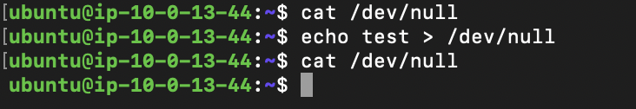

1. Locate the current working directory of your shell process by inspecting **/proc/<pid>/cwd**. You can find the PID of your shell by running **ps**.

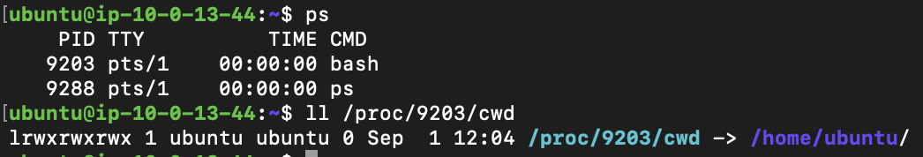

## Lab-5: System Capabilities

1. Display CPU information from **/proc/cpuinfo**.

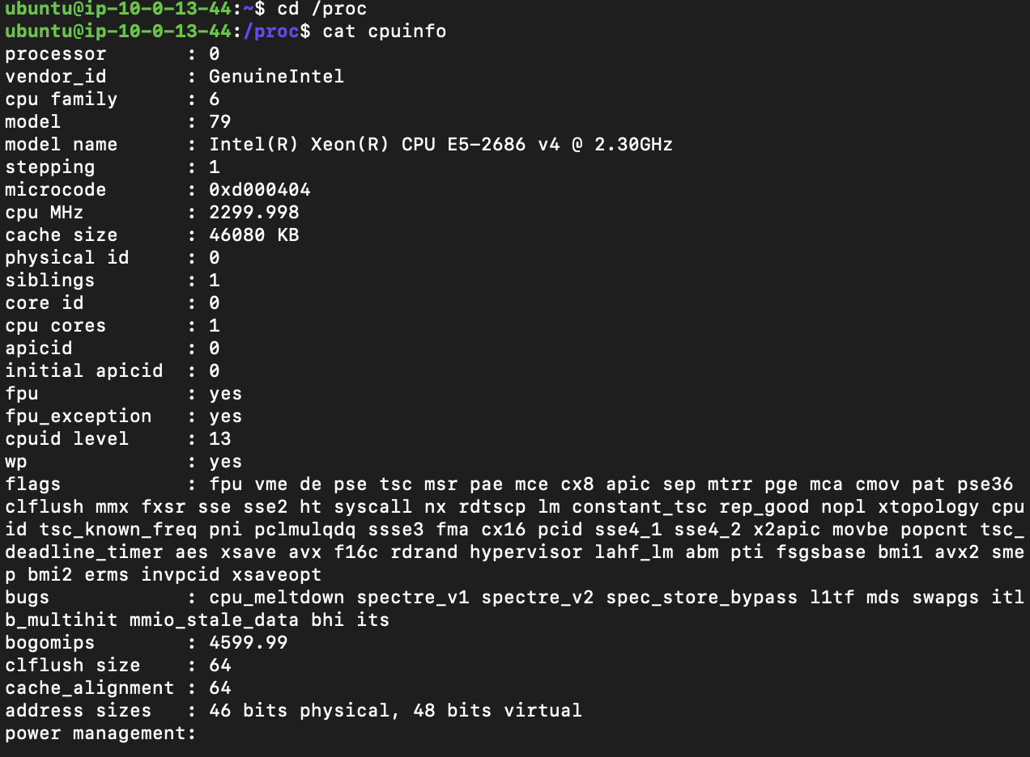

1. Display memory information from **/proc/meminfo**.

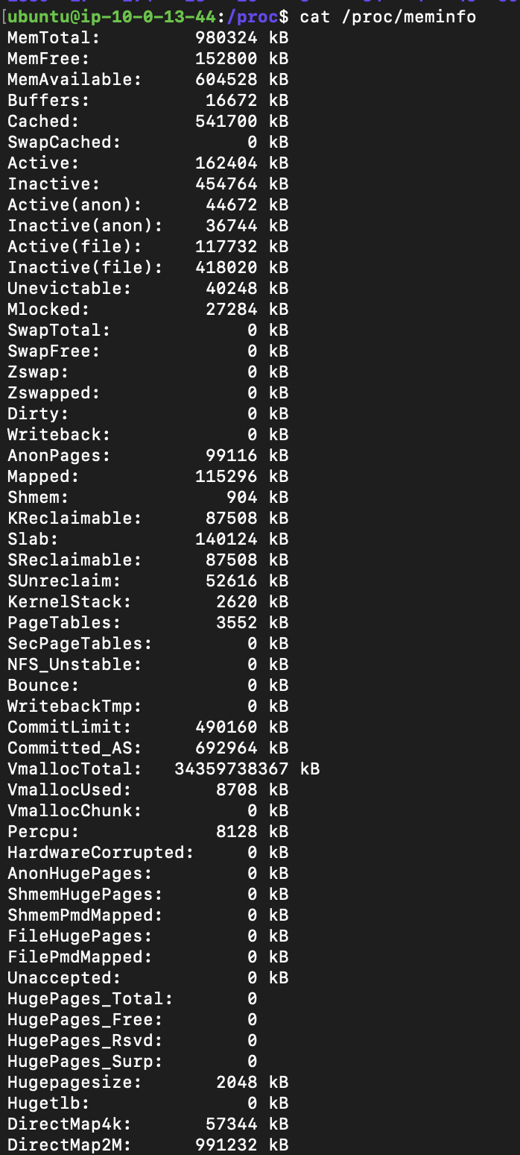

1. Count the number of processes currently running (**ps -ef | wc -l**).



1. Identify how many users are currently logged in (**who**).

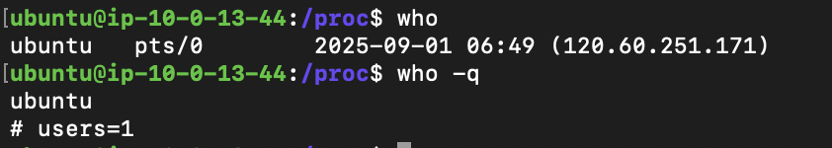

**Short Notes :**

**uname** – system information

**ls** – list directory contents

**lsb_release** – (linux standard base release) Minimal information about distro

**man** – system referrel manual

There are 9 sections in man :

1 User commands

2 System calls (functions provided by the kernel)

3 Library calls (functions within program libraries)

4 Special files (usually found in /dev)

5 File formats and Configuration files

6 Games

7 Miscellaneous (including macro packages and conventions)

8 System administration commands (for root user)

9 Kernel routines (Non – standard)

**man-pages** – contains conventions for writing man pages

**ps** – snapshot of current processes

**wc** – word count

**who** – shows who is logged in

Symlink – (symbolic link) It is file refers to other target file

Filesystem Hierarchy Standard (FHS)

**Referred Resources:**

man pages for ls, lsb_release, uname, man , man-pages, ps, wc ,who

/proc, /etc and other directories

**Online Resources :**

<https://askubuntu.com/tags/symbolic-link/info>

<https://www.geeksforgeeks.org/linux-unix/linux-file-hierarchy-structure/>

<https://roadmap.sh/linux> (getting started)